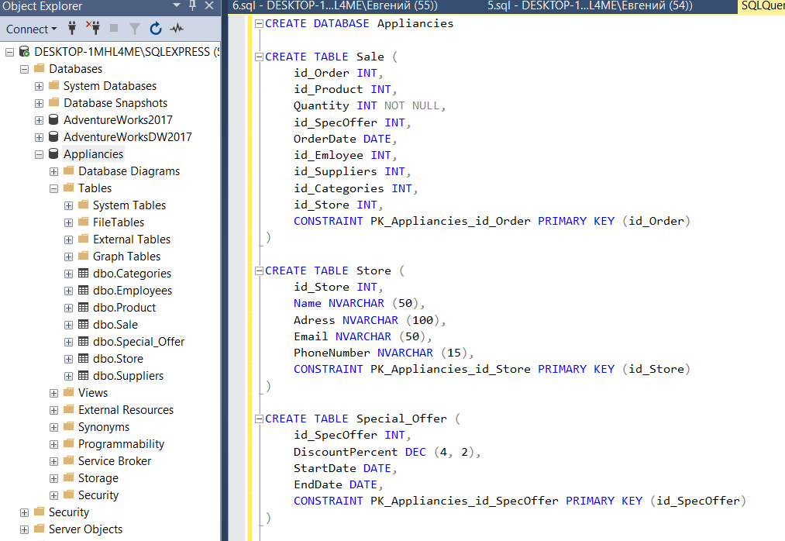

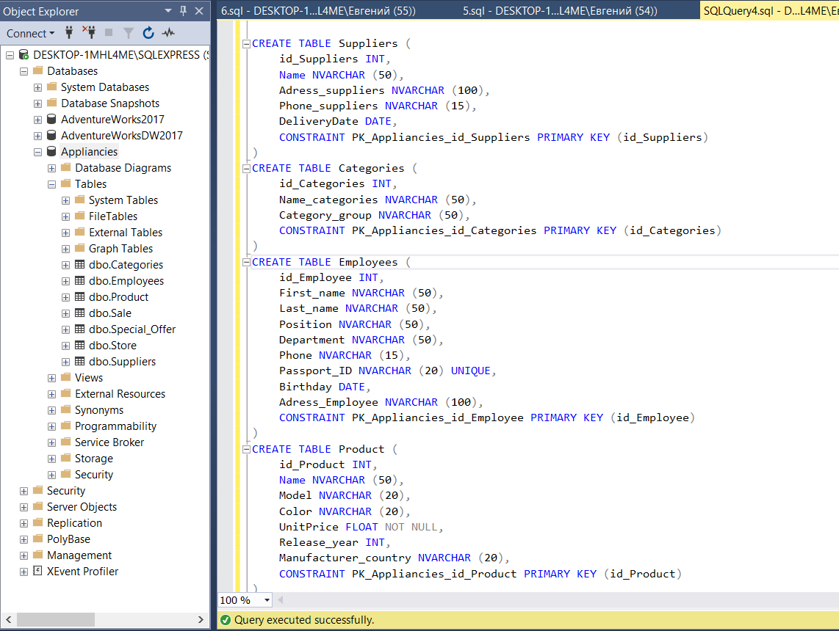

2. SELECT TOP 1000000

a.[first_name],

b.[last_name]

FROM [dbo].[Test1] a

CROSS JOIN

[dbo].[Test1] b

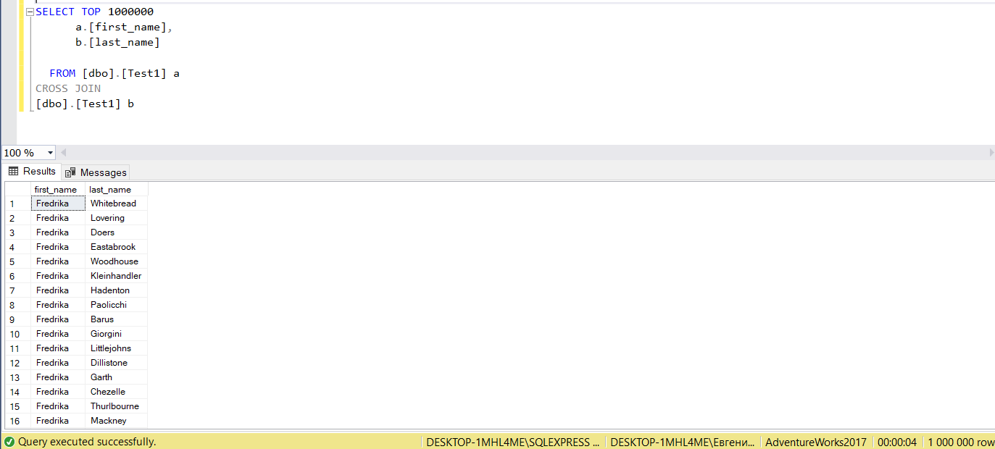

3. We can use CTE WITH for complex queries, because they are easier to work with and more readable. They are used to write recursive queries (which refer to themselves).

CTE WITH is a temporary result defined in a SELECT, INSERT, UPDATE, DELETE, MERGE or CREATE VIEW statement. It can be used instead of VIEW when there is no need to save the view, but only temporarily display the query result.

The difference between CTE WITH and the subquery is that using the WITH CTE you can write a query once and then refer to it, but using a subquery you need to write it each time you need to use it.